1.Write the programme to sort the integers 8, 4, 3,5,6 and the alphabetical string C, O, I, P, U, in ascending order. Show the resulting output.

# **Code:-**

package MyPackage; //importing packages

Import java.util.Arrays;

Public class ArraySorter

{

Public static void main(String[] args)

{

//declaring array of given number

Int[] numbers= {8, 4, 3, 5, 6};

//declaring array of given alphabets

String[] alphabets = {“C”, “O”, “I”, “P”, “U”};

//printing original array of numbers

System.out.println(“Given array of numbers : “ +

Arrays.toString(numbers));

//sorting array of numbers

Arrays.sort(numbers);

//printing sorted array of numbers

System.out.println(“Sorted array of numbers : “ +

Arrays.toString(numbers));

//printing original array of alphabets

System.out.println(“Given array of alphabets : “ +

Arrays.toString(alphabets));

//sorting array of alphabets

Arrays.sort(alphabets);

//printing sorted array of alphabets

System.out.println(“Sorted array of alphabets : “ +

Arrays.toString(alphabets));

}

}

# Output:-

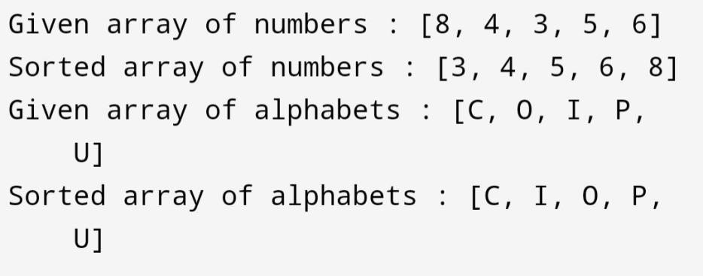

2.Write a Java program to implement the bubble sort algorithm to sort an array of integers in ascending order.

## Code:-

package MyPackage; //importing packages

Import java.util.Arrays;

Public class ArraySorter

{

//creating a function which takes array as arguments

Static void bubbleSort(int[] arr)

{

//getting the length of array

Int n = arr.length;

Int temp;

//outer loop iterate on array elements and inner compare 2 elements of array and place the greatest element at 2nd position and by swapping elements it place the greatest element at end

For (int i=0; i<n-1; i++) {

For (int j=0; j<n-i-1; j++) {

If (arr[j] > arr[j+1]) {

Temp = arr[j];

Arr[j] = arr[j+1];

Arr[j+1] = temp;

}

}

}

System.out.println(“Sorted array using bubble sort algorithm : “ +

Arrays.toString(arr));

}

Public static void main (String[] args)

{

//declaring the array of integers

Int[] num= {8, 4, 7, 3, 9, 5, 2, 6, 1};

//calling the bubbleSort function to sort array by swapping elements bubbleSort(num);

}

}

# Output:-

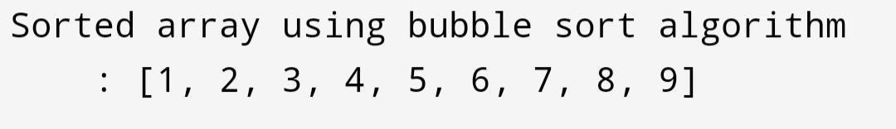

3.Write a program to input an array 10 elements and print the cube of prime numbers in it.

## Code:-

package MyPackage; //importing packages

Import java.util.Arrays;

Import java.util.Scanner;

Public class PrimeNumber

{

Public static void main(String[] args)

{

//creating the object of Scanner class

Scanner sc=new Scanner(System.in);

//declaring array of size 10

Int[] num = new int[10];

//taking input from user and storing in array

System.out.println(“Enter the elements of array : “);

For (int i=0; i<10; i++) {

System.out.print(“Enter element no. “ + (i+1) + “ : “);

Num[i] = sc.nextInt();

}

//printing the array

System.out.println(“Array of 10 numbers : “ + Arrays.toString(num));

System.out.println(“Prime numbers and their cube : “);

//advanced for loop iterate over array

For (int n : num) {

Int count = 0;

//inner loop take the element of array and divide it by number from 1 to number equal to array element

For (int j=1; j<=n; j++){

//if number is divided by then int increment the count variable by

1

If (n % j == 0) {

Count++;

}

}

//if value of count variable is equals to 2 means the number is has only to divisor 1 and number itself means the number is prime number //since the prime number has only one divisor 1 and number itself

If (count == 2) {

//it will print the number and its output

System.out.println(n + “ = “ + n*n*n);

}

}

}

}

# Output:-

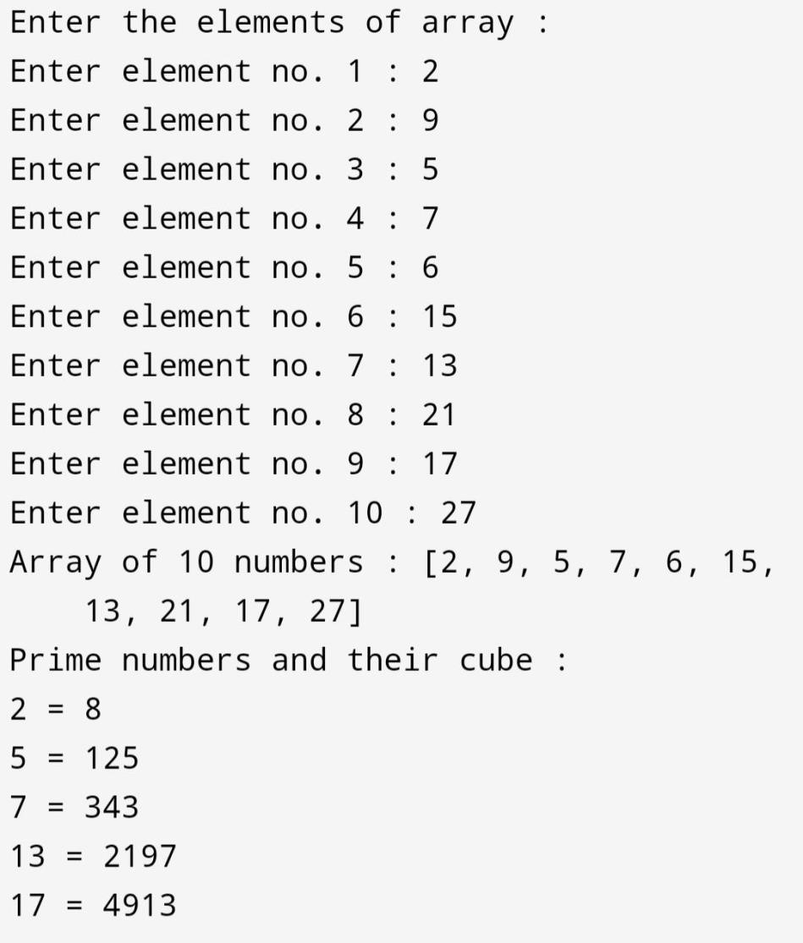

4.Write a java program to implement integer wrapper class methods.(any 3 methods)

Code:-

package MyPackage; public class IntegerMethods

{

Public static void main (String[] args)

{

//creating object of integer wrapper

Integer num1 = new Integer(50);

Integer num2 = new Integer(70);

// valueOf method

System.out.println(“Printing the value of num1: “ +

Integer.valueOf(num1));

// compare to method

//num1 < num2 = -1

//num1 = num2 = 0

//num1 > num2 = 1

System.out.println(“Comparing num1 and num2 : “ + num1.compareTo(num2));

// parse int method

String strNum = “25”;

Int parsedNum = Integer.parseInt(strNum);

System.out.println(“Parsed Integer value : “ + parsedNum);

}

}

# Output:-

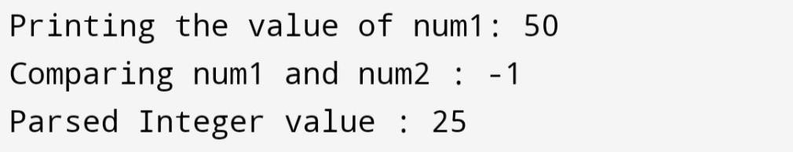

5.Write a java program to implement double wrapper class methods.(any 3 methods)

Code:-

package MyPackage; public class DoubleMethods

{

Public static void main (String[] args)

{

//creating object of Double wrapper

Double num1 = new Double(40.5);

Double num2 = new Double(30.5);

// valueOf method

System.out.println(“Printing the value of num1: “ +

Double.valueOf(num1));

// compare to method

//num1 < num2 = -1

//num1 = num2 = 0

//num1 > num2 = 1

System.out.println(“Comparing num1 and num2 : “ + num1.compareTo(num2));

// parse int method

String strNum = “25”;

Double parsedNum = Double.parseDouble(strNum);

System.out.println(“Parsed Double value : “ + parsedNum);

//NaN method

System.out.println(“Checking num1 is not a number : “ + num1.isNaN());

}

}

# Output:-

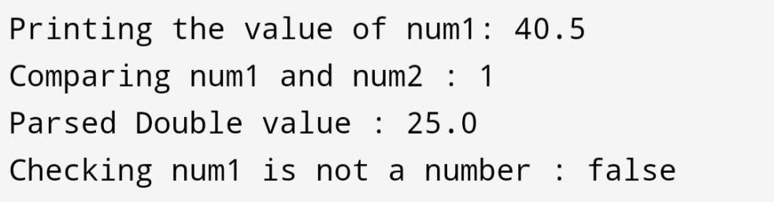

6.Write a java program to implement float wrapper class methods.(any 3 methods)

Code:-

package MyPackage; public class FloatMethods

{

Public static void main (String[] args)

{

//creating object of Float wrapper

Float num1 = new Float(30.5f);

Float num2 = new Float(30.5f);

// valueOf method

System.out.println(“Printing the value of num1: “ +

Float.valueOf(num1));

// compare to method

//num1 < num2 = -1

//num1 = num2 = 0

//num1 > num2 = 1

System.out.println(“Comparing num1 and num2 : “ + num1.compareTo(num2));

// parse int method

String strNum = “25”;

Float parsedNum = Float.parseFloat(strNum);

System.out.println(“Parsed Float value : “ + parsedNum);

//NaN method

System.out.println(“Checking num1 is not a number : “ + num1.isNaN());

}

}

# Output:-

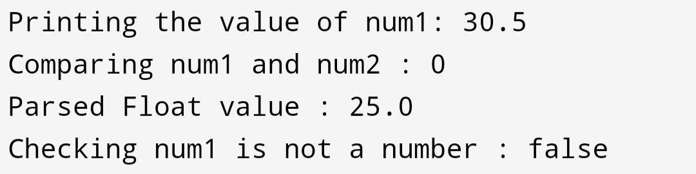

7.Write a Java program to validate email addresses using regular expressions. The email should have the format username@domain.com where username and domain can contain alphanumeric characters, dots, and hyphens.

Code:-

package MyPackage; //importing packages

Import java.util.regex.*;

Import java.util.Scanner;

Public class EmailValidator

{

Public static void main(String[] args)

{

//creating a email pattern

String emailPattern = “^[a-zA-Z0-9.-]+@[a-zA-Z0-9.-]+\\.(com)$”;

//storing pattern

Pattern p = Pattern.compile(emailPattern);

//creating object of Scanner

Scanner sc = new Scanner(System.in);

//taking user input

System.out.print(“Enter your email : “);

//storing user input

String email = sc.nextLine();

//matching email with pattern

Matcher m = p.matcher(email);

//validating email if matches

If (m.matches()) {

System.out.println(email + “ is a vailid email.”);

} else {

System.out.println(email + “ is an invailid email.”);

}

}

}

# Output:-

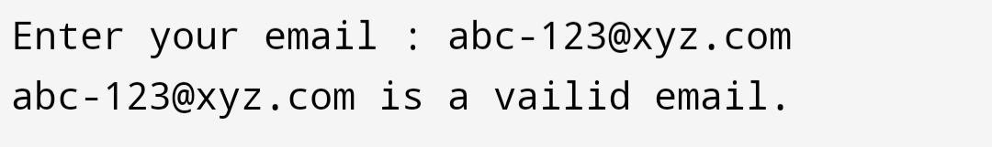

8.Create a Java program to validate phone numbers. The format should be (xxx) xxx-xxxx where x is a digit.

Code:-

package MyPackage; //importing packages

Import java.util.regex.*;

Import java.util.Scanner;

Public class PhoneNumberValidator

{

Public static void main(String[] args)

{

//creating a phone number pattern

String numberPattern = “^\\(\\d{3}\\) \\d{3}-\\d{4}$”;

//storing number pattern

Pattern p = Pattern.compile(numberPattern);

//creating object of Scanner

Scanner sc = new Scanner(System.in);

//taking user input

System.out.print(“Enter your phone number : “);

//storing user input

String number = sc.nextLine();

//matching number with pattern

Matcher m = p.matcher(number);

//validating number if matches with number pattern

If (m.matches()) {

System.out.println(number + “ is a vailid number.”);

} else {

System.out.println(number + “ is an invailid number.”);

}

}

}

# Output:-

